SYNOPSIS

ON

“DROWSINESS DETECTION SYSTEM”

Submitted in

Partial Fulfillment of requirements for the Award of Degree

of

Bachelor of Technology

In

Computer Science and Engineering
(Artificial Intelligence)
By

(Project Id: 26_CSAI_3C_05)

Srishti Sachan (2301641520184)

Shreya Gupta (2301641520171)

Suksham Srivastava (2301641520185)

Sanchit (2301641520153)
Sanskriti Gupta (2301641520156)
Ansh Nigam (2201641520202)

Under the supervision of
Kumari Srishti
(Assistant Professor)


Pranveer Singh Institute of Technology.
Kanpur - Agra - Delhi National Highway - 19
Bhauti -Kanpur - 209305.
(Affiliated to Dr. A.P.J. Abdul Kalam Technical University)

Introduction

The proposed project, Drowsiness Detection System, aims to enhance road safety by identifying signs of driver fatigue in real time and alerting them to prevent accidents. Driver drowsiness is a significant cause of road accidents worldwide, and timely detection can greatly reduce such incidents.

This project falls under the domain of Computer Vision and Artificial Intelligence (AI), specifically leveraging image processing and machine learning techniques to analyse the driver’s facial features and eye activity. The system uses a camera to continuously monitor the driver’s face, detecting indicators such as prolonged eye closure, slow blinking rate, and head movement patterns.

Special technical terms associated with this project include:

Face Detection – Identifying and locating the driver’s face in video frames.

Eye Aspect Ratio (EAR) – A mathematical measure used to determine if eyes are closed.

Real-Time Processing – Immediate analysis of video input to ensure timely alerts.

Computer Vision – Technology that enables machines to interpret visual data.

The system is designed to be lightweight, efficient, and deployable on devices such as laptops, Raspberry Pi, or embedded vehicle systems. With a combination of OpenCV for image processing and deep learning models for accurate detection, this solution offers a proactive approach to road safety.

2. Project Objective

The primary objective of this project is to design and develop a vision-based drowsiness detection system that can monitor driver alertness in real-time and generate timely alerts to prevent accidents caused by fatigue. By the end of the project, the system will be capable of:

Accurate Monitoring of Driver Fatigue: Implement image processing and machine learning techniques to analyze facial landmarks such as eye aspect ratio (EAR), blink frequency, and head pose to detect signs of drowsiness.

Real-Time Detection and Alert Mechanism: Develop a responsive system that continuously processes live video feed from a camera module and triggers immediate alerts (audio/visual signals) when drowsiness is detected.

User-Friendly and Cost-Effective Prototype: Design a lightweight and affordable system that can be integrated into vehicles or workplace environments without requiring complex hardware.

Enhanced Road Safety and Accident Prevention: Assist drivers by minimizing risks associated with fatigue-induced accidents, thus contributing to safer transportation systems.

Scalability and Adaptability: Provide a framework that can be extended to other domains, such as industrial safety monitoring, intelligent surveillance, and healthcare applications.

By fulfilling these objectives, the project aims to deliver a proactive safety solution that helps end users—especially drivers—remain attentive and reduces the likelihood of accidents caused by drowsiness.

Feasibility Study:
The feasibility study evaluates whether the proposed Drowsiness Detection System is practical, achievable, and beneficial for its intended users. It examines various factors to determine the success potential of the project.

1. Technical Feasibility
The project leverages widely available hardware and software components. A standard USB or in-built camera will capture real-time video, while OpenCV, Python, and deep learning libraries such as TensorFlow will be used for face and eye detection. The technology is proven and compatible with low-cost computing platforms, ensuring that the solution can be deployed easily.

2. Operational Feasibility
The system is user-friendly and requires minimal technical knowledge from the end-user. It works automatically once started and provides timely alerts without driver intervention. Its integration into vehicles can be done without major modifications, making it suitable for personal, commercial, and public transportation sectors.

3. Economic Feasibility
The cost of development is minimal due to the use of open-source software and affordable hardware. This makes it economically viable for individual users and organizations such as transport companies. The long-term savings from accident prevention outweigh the initial development costs.

4. Schedule Feasibility
The project is planned to be completed within three months (16 August 2025 – 20 November 2025) as per the prepared Gantt Chart. Each phase — from requirement analysis to final submission — is well-defined, ensuring timely delivery.

5. Legal Feasibility
The system complies with data privacy regulations as it processes video streams in real time without storing personal data unless explicitly permitted. It follows ethical AI practices and adheres to road safety guidelines.

Conclusion:
The feasibility study confirms that the Drowsiness Detection System is technically achievable, operationally practical, economically viable, legally compliant, and can be completed within the given schedule. The project has strong potential to improve road safety and save lives.

Start Date: 16-Aug-2025 End Date: 20-Nov-2025.

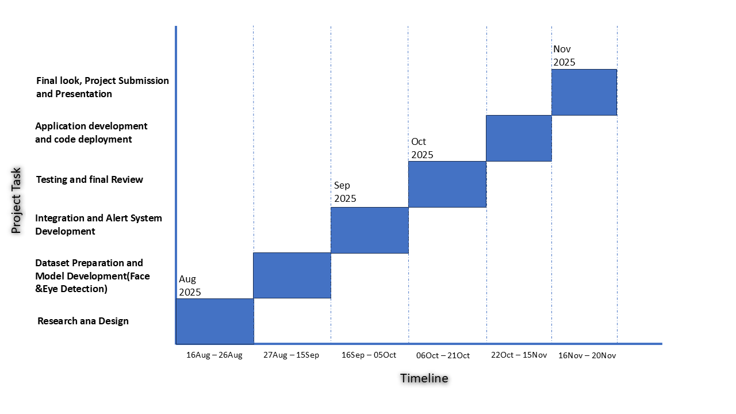

4. Methodology/ Planning of work:

The development of the Drowsiness Detection System will follow a systematic approach to ensure accurate, efficient, and real-time detection of driver fatigue. The steps involved are:

Step 1: Requirement Analysis & Research

Identify system requirements (hardware, software, libraries).

Study existing drowsiness detection methods and relevant literature.

Step 2: System Design & Planning

Design the architecture of the system including camera integration, detection modules, and alert mechanisms.

Prepare the workflow for real-time video processing.

Step 3: Data Collection & Dataset Preparation

Gather datasets of facial images showing open eyes, closed eyes, and different head positions.

Preprocess images (resize, normalize, augment) for training.

Step 4: Model Development

Implement face detection using Haar Cascades / Dlib / MTCNN.

Implement eye detection and calculate Eye Aspect Ratio (EAR).

Apply thresholding to determine if eyes are closed for a prolonged period.

Step 5: Alert System Integration

Trigger an audio alert when drowsiness is detected.

Ensure alerts are immediate and non-distracting.

Step 6: Testing & Debugging

Test the system in simulated and real driving conditions.

Adjust parameters for accuracy and reduce false alarms.

Step 7: Final Review & Documentation

Prepare project documentation.

Create a final demonstration for evaluation.

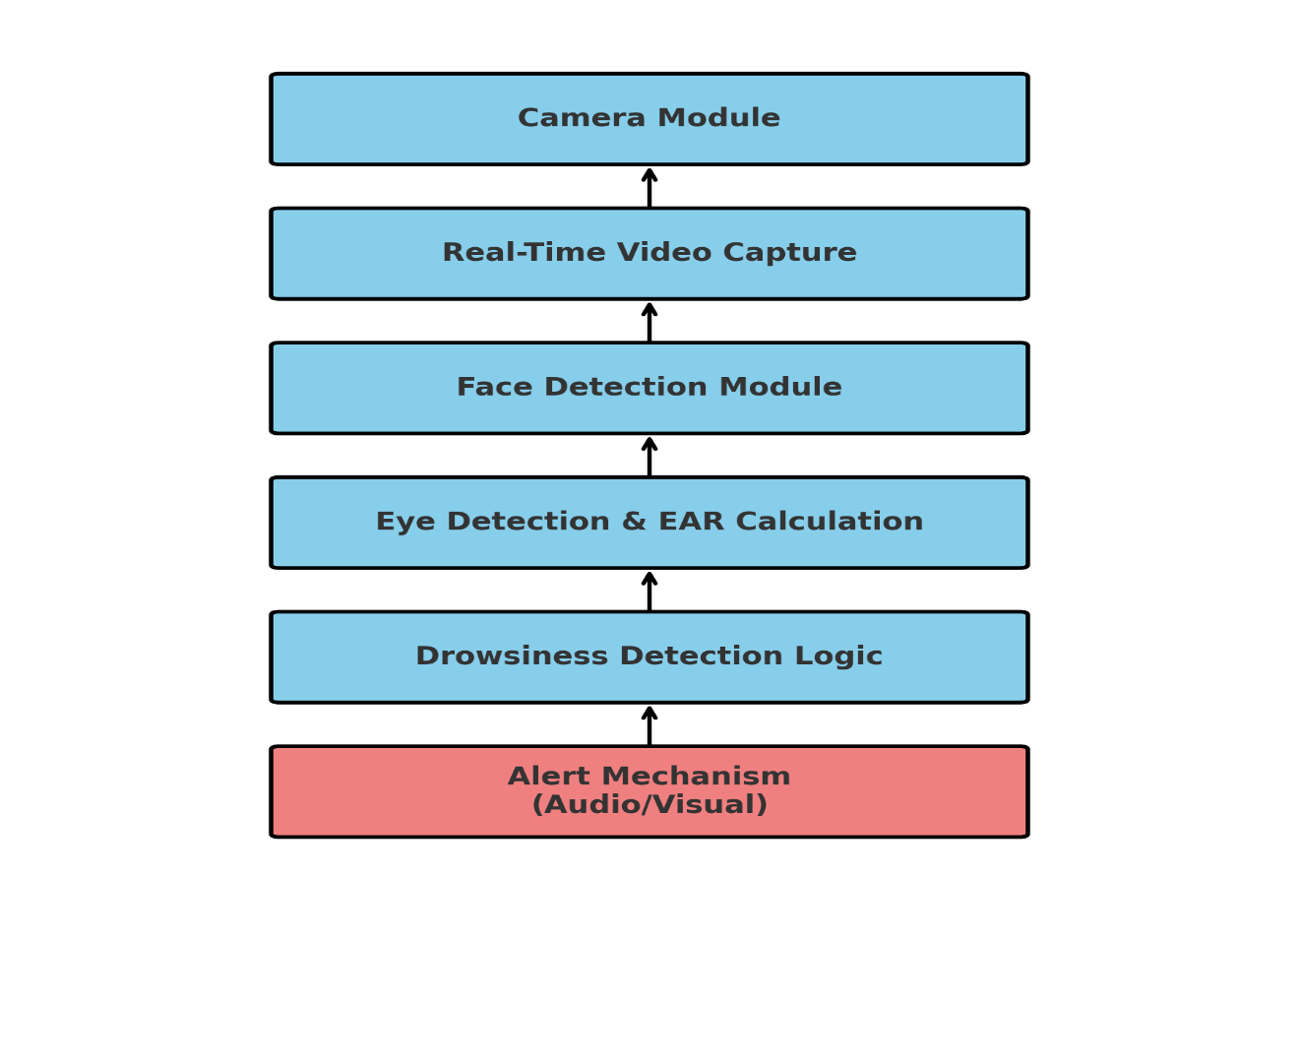

5. Tools/Technology Used:

5.1 Minimum Hardware Requirements:

Hardware required for the development of the project.
- CPU: Intel i5/i7 (8th Gen or newer) or AMD Ryzen 5
- RAM: Minimum 8 GB (16 GB recommended for smooth processing)
- Storage: 256 GB SSD or higher for faster processing and data handling
- Graphics Card: NVIDIA GPU (CUDA support preferred)
- Others: Standard webcam/USB camera for video input, microphone (for audio alerts), speakers

5.2 Minimum Software Requirements:

Software required for the development of the project.
- Operating System: Windows 10/11 (64-bit)
- Development Tools: Python 3.8+ (with IDE such as VS Code)
- Development Environment: VS Code
- Database: MySQL (for storing logs)
- Web Browser: Chrome
- Libraries & Frameworks:

OpenCV – For image processing and video capture

MediaPipe – For face and eye landmark detection

NumPy – For numerical computations

Pygame – For playing audio alerts

TensorFlow – For any deep learning model implementation

6. References:
- R. K. Mega lingam, S. B. Jacob, and S. Sreekumar, “Real time non-intrusive driver drowsiness detection,” 2018 International Conference on Communication and Signal Processing (ICCSP), Chennai, India, Apr. 2018, pp. 0649–0653, Doi: 10.1109/ICCSP.2018.8524465.
- OpenCV Documentation, “Face detection and tracking,” OpenCV.org. [Online]. Available: https://docs.opencv.org/

